1. **When to use Pessimistic Locking**?
2. [Pessimistic locking](https://chatgpt.com/c/670b7f71-86e8-8004-a0fe-7e8dbbe6e897#:~:text=Refined%20Definition%3A-,Pessimistic%20locking,-is%20a%20technique) is a technique used in transactions to lock data immediately upon reading to prevent other transactions from modifying it while it is being used. This is especially useful when multiple queries are executed (to read same data. That is important.) within a single transaction and there is a time lag between the queries, as it ensures data consistency by blocking other transactions from updating the locked data until the transaction is complete.  
   
3. **Example**:  
   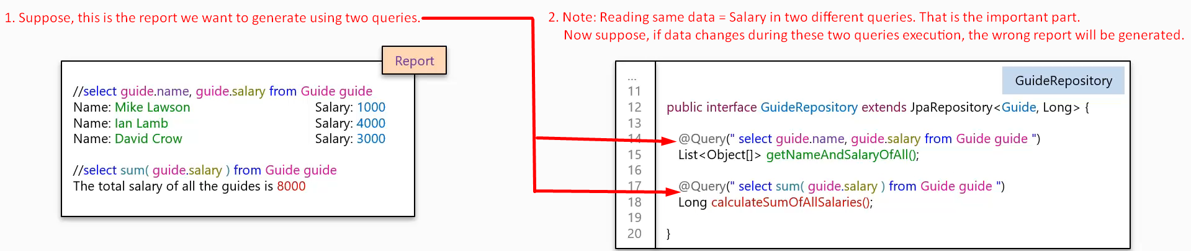
4. 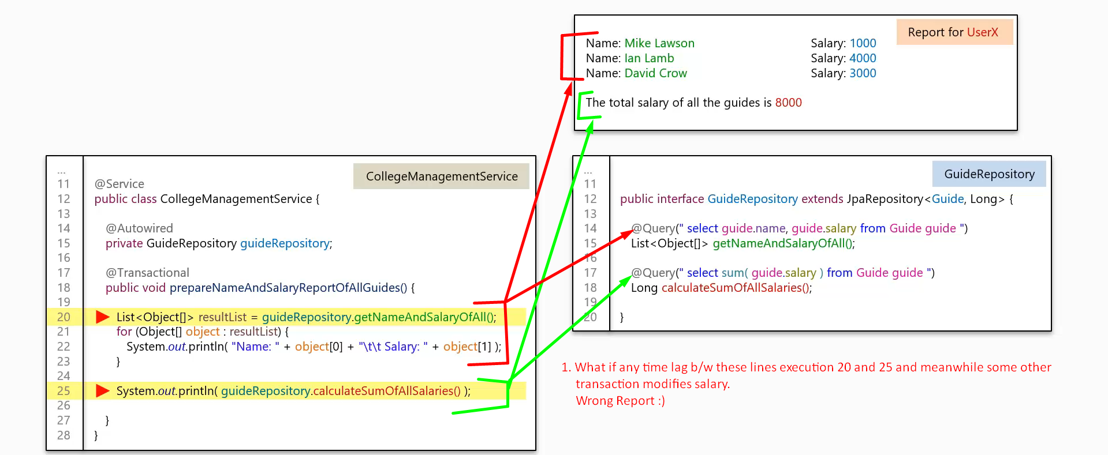
5. How to lock data pessimistically.   
   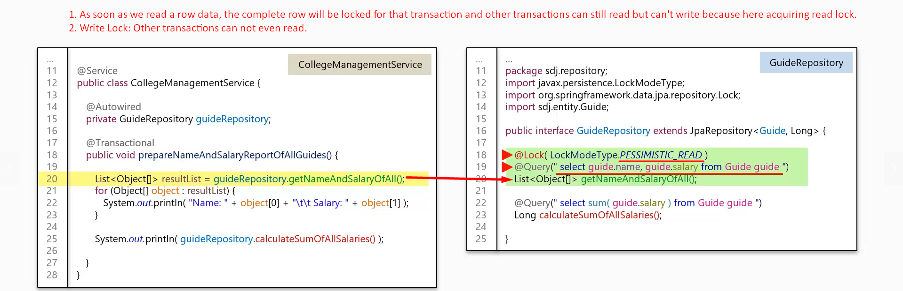
6. 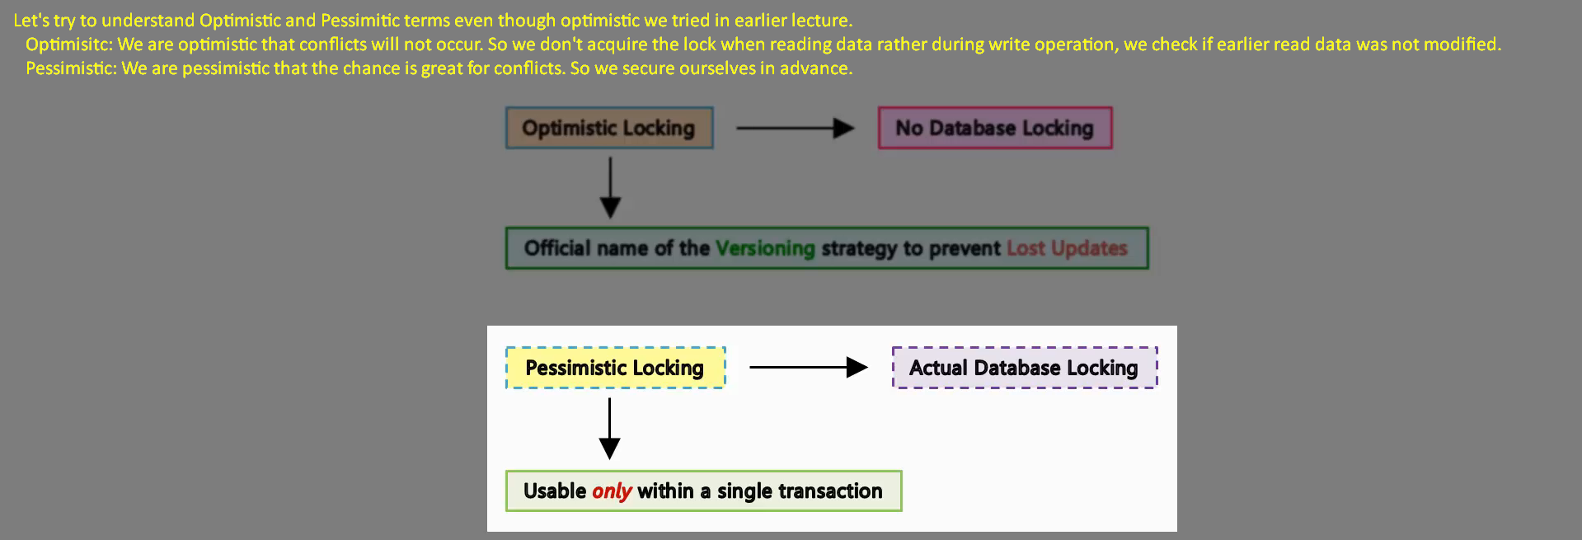
7. 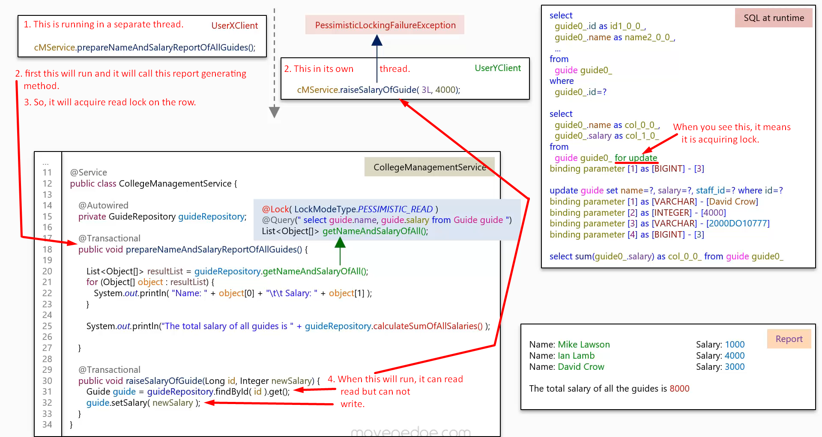
8. 